CSC103 Programming Fundamentals Methods

# LAB TASKS

1. Do all the examples done in class.
2. package com.company;  
   import java.util.Scanner;  
   public class Main{  
    public static void main(String[] args) {  
    Scanner sc = new Scanner(System.*in*);  
    System.*out*.print("enter marks");  
    int marks = sc.nextInt();  
    System.*out*.println("Grade "+ *grade*(marks));  
    }  
     
    public static char grade(int avg)  
    {  
    if(avg>=80)  
    {  
    return 'A';  
    }  
    else if(avg>=60 && avg<80)  
    {  
    return 'B';  
    }  
    else if(avg>=40 && avg<60)  
    {  
    return 'C';  
    }  
    else  
    {  
    return 'D';  
    }  
    }  
   }
3. A pentagonal number is defined as n(3n – 1)/2 for n = 1, 2, 3, …, and so on. Write a method with the following header that returns a pentagonal number:

**public static int getPentagonalNumber(int n)**

Write a test program (the main() method) that uses the above method to display the first 100 pentagonal numbers with 10 numbers on each line.

1. Write a method that computes the sum of the digits in an integer. Use the following method header:

**public static int sumDigits(long n)**

Write a test program that prompts the user to enter an integer and displays the sum of all its digits. The integer can have any number of digits; e.g. n can be 123 or 2345 or 789001.

1. Input a string from user. Write two methods: 1) reverse the string, 2) check if the string is palindrome. The methods will have the following headers.

**public static String reverse(String s) public static boolean isPalindrome(String s)** 5. Implement and test the following methods.

**public static int length(String s)**

**public static String substring(String s, int start, int end)**

Do not use built-in String methods of finding length and getting substring.

1. Write a method with the following header to display three numbers in increasing order:

**public static void displaySortedNumbers(int num1, int num2, int num3)**

1. Write a method to display following pattern.

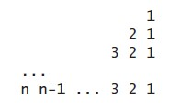

The method header is **public static void displayPattern(int n).**

1. Write a method that checks whether a number is a prime number. The method will have the header **public static boolean isPrime(int number)**. Test the method by inputting a number from user and passing it to this method.

CSC103 Programming Fundamentals Methods

1. Write a method to compute the following series:

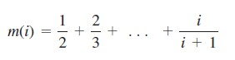

Write a test program that displays the following table:

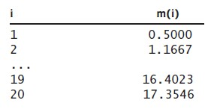

1. Write a method that returns the number of days in a year using the following header: **public static int numberOfDaysInAYear(int year)**

Write a test program that displays the number of days from 2000 to 2020.

1. Listing 5.6 page 189
2. Listing 5.7 page 190
3. Listing 5.8 page 192
4. Listing 5.10 page 202
5. Listing 5.12 page 208

## FOR PRACTICE AT HOME

### THE MATH CLASS

Solve as much programming exercises as possible from 5.17 (page 215) onwards.